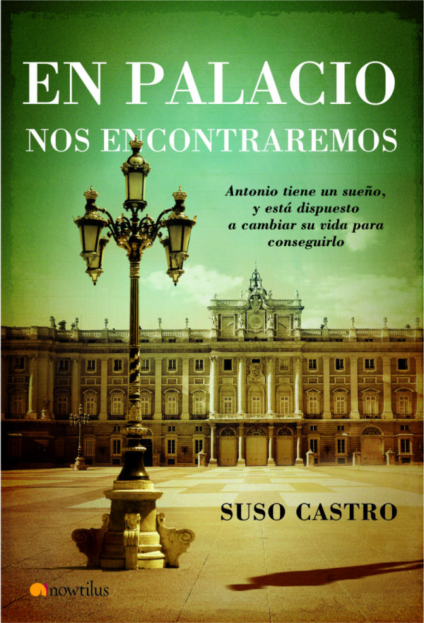
WE WILL MEET AT THE PALACE
Antonio has a dream and is willing to change his life in order to make it come true.
Suso Castro
Collection: Narrativa/ Fiction, www.novelanowtilus.com
16 x 23.5 cm
Binding: Hardcover with dust jacket
288p
ISBN13: 978-849763375-8
SRP: 19.95 euros
Publishing date: October 2007

Antonio, a solitary 37 year old man, changes his life drastically in order to make his dream come true. From that moment on, he will find love and embark on a project that will be of great significance to the people around him and will turn him into a different person from the one he had been so far.

Original and ironic, We Will Meet at the Palace is the story of Antonio, of the radical changes that take place in his life from the day he decides to prove ―by means of a simple idea― that time travel is possible. To do that, he has to start by changing the personality he used to have until then, opening up to people, and being willing to share his life with others.
From that moment on, events succeed each other dizzily. Antonio finds love in Julia, a charming woman who has been unlucky so far. At the same time, he sets up a successful social plan that will affect the lives of the people around him.
This way, before knowing whether Antonio’s dream comes true, you will learn the story of a man who decides to change his life and manages to leave a mark on the people around him and on future generations.

This is a vitalistic, warm novel written in a direct, simple, but precise language that has been cleverly developed not only to narrate but also tell, suggest, and confide to you the illusions, frustrations and dreams of the main character, who, despite everything, has the feeling that it is very important to enjoy life as it is for happiness can be found in the least expected place and time.

Suso Castro. In 1962, the city of Murcia witnessed his birth and his departure, always in the company of his parents. He spent his childhood placidly and healthily in Madrid and in the friendly city of La Coruna. Later, he lived for some time in Zaragoza, where he started out as a writer as he was forced to start writing letters in order to communicate with his girlfriend. In 1989, he married the addressee of those letters and had two children. Subsequently, armed with courage and patience, he began to write ―during his very little spare time― We Will Meet at the Palace, which, after a lot of creative effort, has become his first novel.

