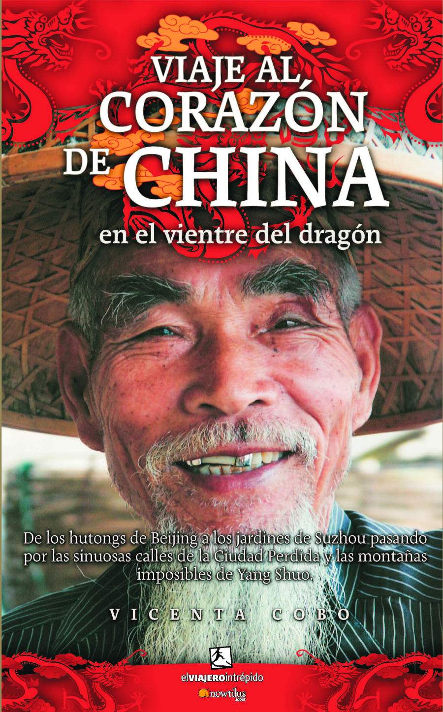

A JOURNEY TO THE HEART OF CHINA
IN THE BOWELS OF THE DRAGON
From Beijing’s hutongs to the gardens in Suzhou, going through the Forbidden City’s winding roads and the wonderful mountains in Yangzhuo.
Vicenta Cobo
Traveling/Popular History
17x24 cm
Binding: Hardcover with dust jacket
Color. Ample illustrations
208 p
ISBN13: 978-84-9763-450-2
SRP: 19.95 €
Collection: El viajero intrepid/ The Intrepid Traveler, www.viajerointrepido.com
Publishing date: October 2007
Includes a preface written by the famous journalist and traveler, Pablo Villarrubia

This is an exciting visual journey around the most emblematic places of this millenarian Eastern civilization’s culture and history. It is also a journey into the bowels of the dragon, which wakes up and devours its offspring incited by the excessive consumerism and communism.

An airplane ticket to Beijing, a Spanish-Mandarin dictionary, and a globetrotters’ guide were the only objects Vicenta Cobo had in her backpack when she decided to travel to this great Eastern country. This fascinating and human story stems from the experiences the writer had during this journey. It is a gripping chronicle of adventures written by a journalist as a tourism and social article in a clear, concise, vitalistic language, with fast rhythm, which gives you the possibility to know, in detail, the heart of modern and millenarian China...
The Great Wall of China, the Forbidden City’s winding roads, the mythical Xi'an's Terracotta Army or the spectacular mountains in Yangzhou let you into the secrets of an ancient civilization which is torn between savage capitalism and communism, an unprecedented combination in the history of humankind.

Vicenta Cobo is a journalist and a teacher. She has worked as a journalist in the press, the radio and the television for over twenty years. At present, she is linked to education as she teaches Media, Audio and Visual Arts in Madrid. Inveterate traveler, she has visited twenty five countries around the five continents.

